- How do we represent data? Name two different data types and their standards.
- A signal with 300 milliwatts power passes through 5 devices, each with an average noise of 2 microwatts. What is the SNR? What is the SNRdB?
- Which layer(s) are involved in encrypting the data of a packet? Which address(es) does not change at each hop?
- Complete the frames (x & y) given below with appropriate port, IP and MAC addresses. The sender Host E has two applications running; one for email with port number 49170 and the other for accessing the web server with port number 51033. The frame x is intended for the BRACU Web server and frame y is coming from the Email Server. (MAC addresses are alphabets and IP addresses are numbers)
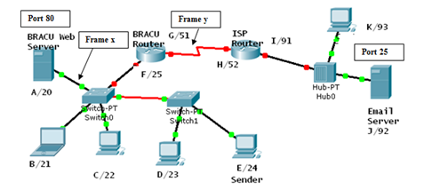

Frame X
D. Mac | S. MAC | D. IP | S. IP | D. Port | S. Port | Data | Trailer

Frame Y
D. Mac | S. MAC | D. IP | S. IP | D. Port | S. Port | Data | Trailer

- Between a high SNR and a low SNR, which one is more desirable? Explain why.
- Write the differences between baseline wandering and DC component and its effect on digital transmission.
- The figure below represents the Differential Manchester encoding of a data stream. What is the data stream? D. Manchester does not require block coding, explain briefly.
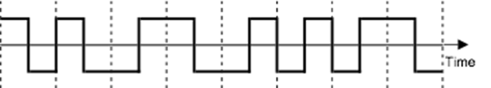
- Differential Manchester solves a number of common problems that occur in signal encoding processes, what are they and how are they solved?
- What is the advantage and disadvantage of using Block Coding signal encoding technique? Convert the Data 1000011010101011001 into signal using 4B/5B block coding technique with MLT-3 line coding scheme. The table below shows the substitution of blocks.
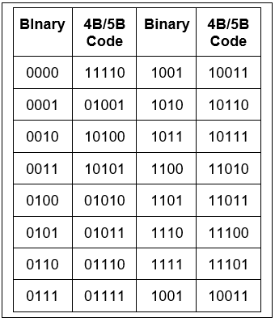
- Define PCM. Explain the PCM quantization technique of an analog signal with appropriate diagram and calculation.

